**TEAM 2 - WEEK 4 REPORT - FEB 21st - 408i SPRING 2022**

**Michael Delatte**

This week Michael has a working matlab maze system, that is ready to implement basic alorightm to solve the maze. It has a solid UI as well, which makes visualizing the efficiency of our algorithms easy. Not much testing has been done with this due to most of my time being spent researching machine learning. Once he has finished the google Co-lab notebooks, he will convert the matlab code into python code, and attempting to train the robots on a few thousand mazes.. Having the fallback of the matlab code, is vital in case the ML route does not produce what we hope.

**Wesley Catbagan**

This week Wesley spent his time in lab working on testing the map code that he had made previously. He did so by writing code for the motors to follow specific paths and then checking to see if the map matched up. He ran into some issues and is working to solve them. In the next lab he will spend time making sure that the map will work when the motors are running and make sure that the path it follows is accurately tracked in the map. Once this is corrected, he will work with Eric to test with our PID controller and also with Michael to test with our maze solver.

**Erik Bryson**

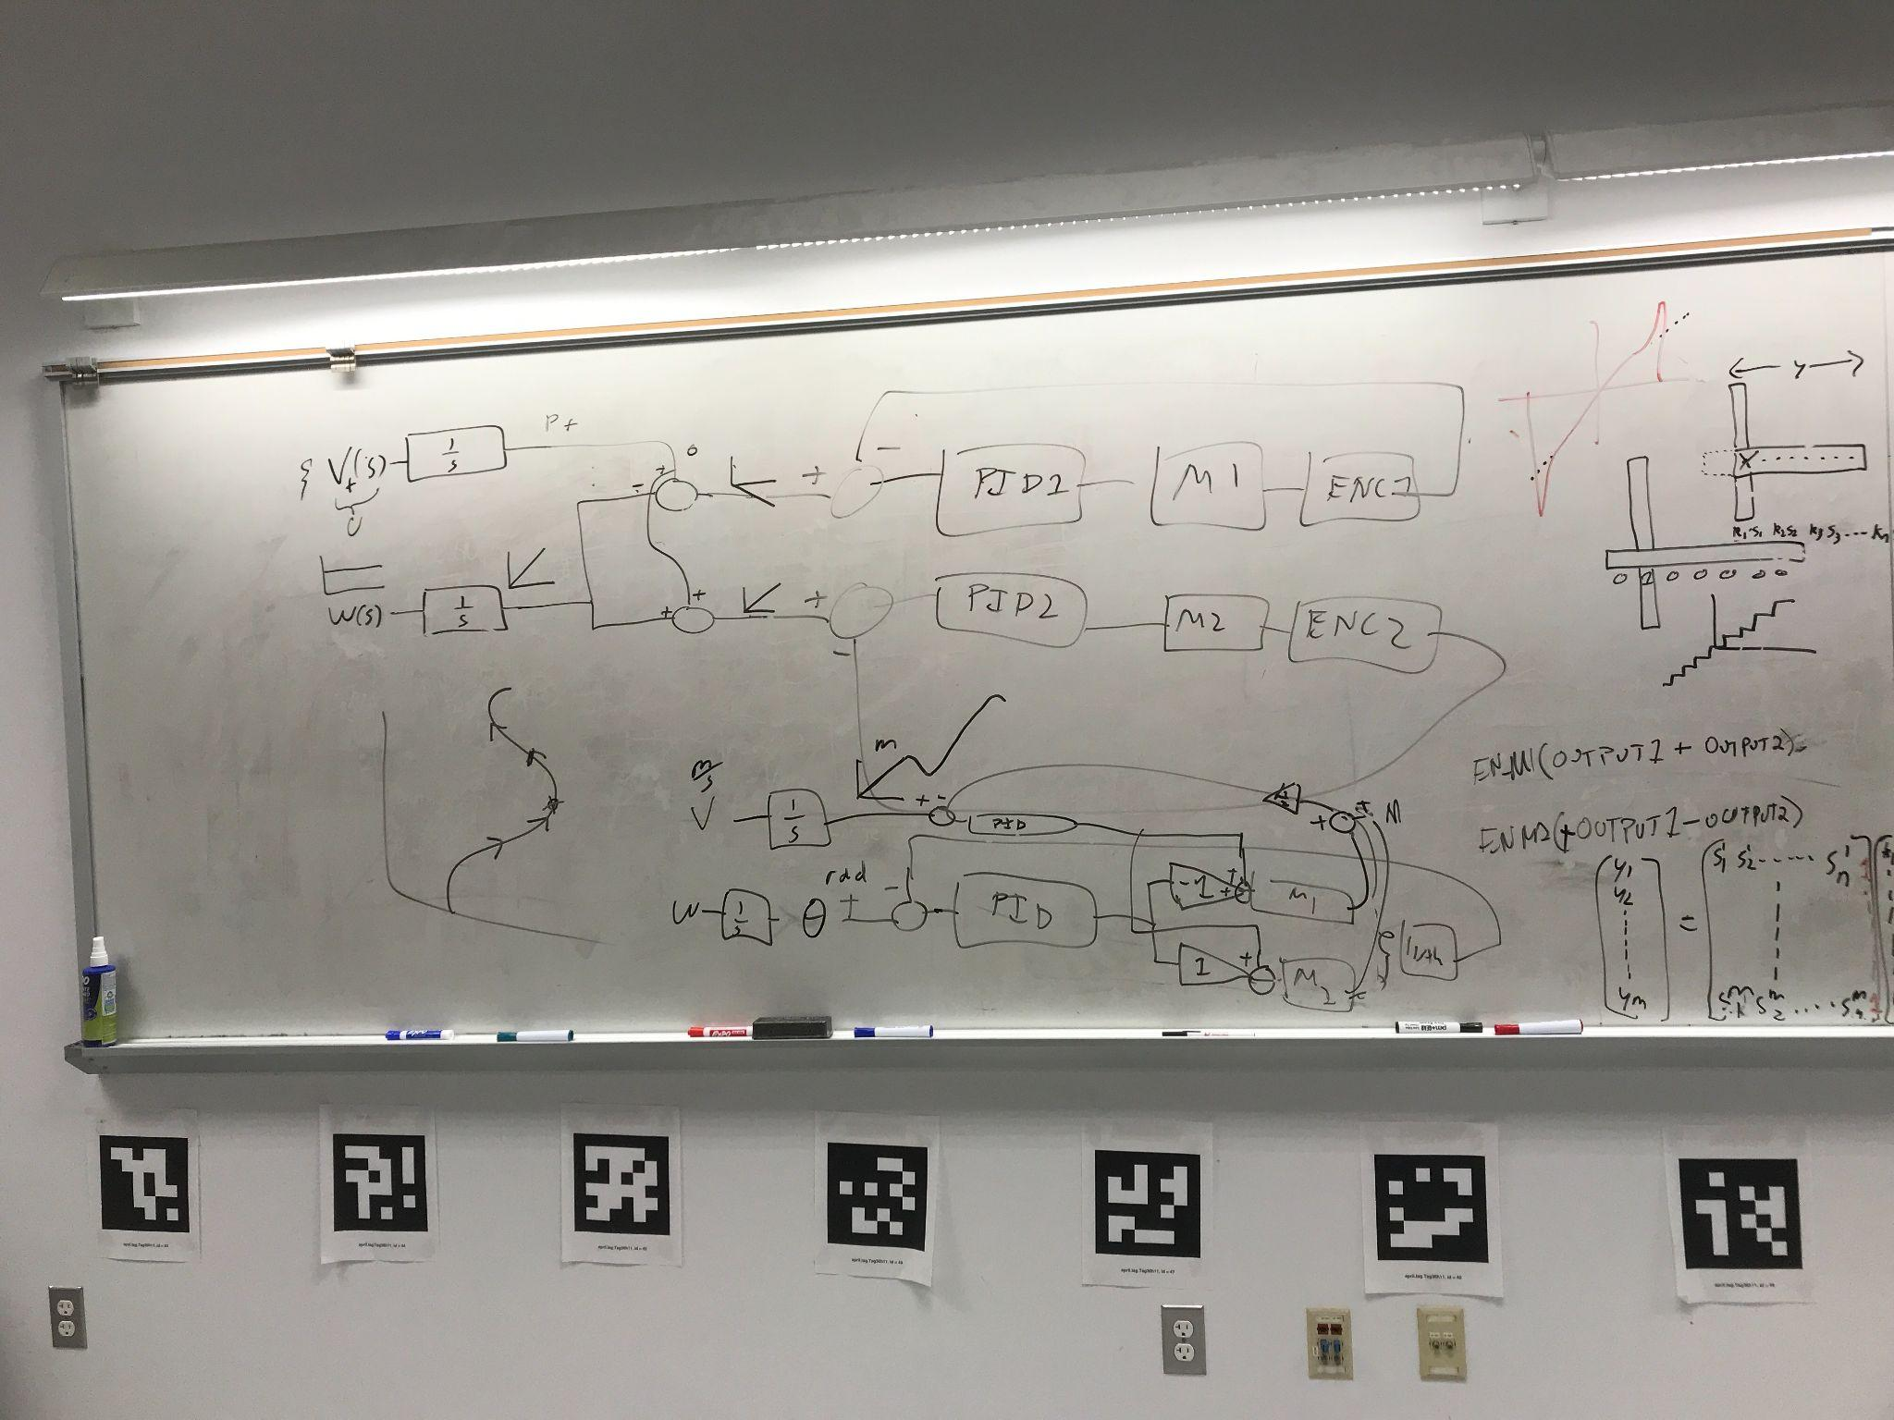

On new ground. I abandoned my own attempts at manually creating a PID function, and opted for the more soccer mom route of selecting an off the shelf library, and boy that that seemed the right move. The art of delegating various PID’s has begun, much in thanks to Levi, who spent a good 15 minutes of his time with me on the whiteboard. We worked through how to interconnect separate governing PID’s for maintaining forward movement while also line tracking.

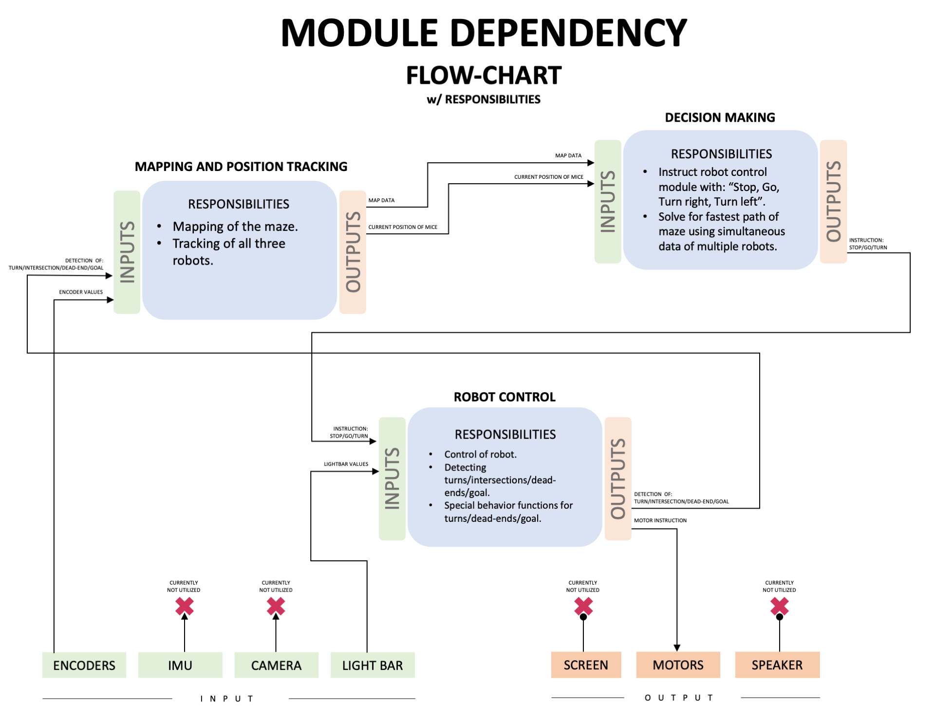

The team explorative enginuity largely I feel weighs on me to get us a moving robot, so that we can get developing on the other aspects of the mission. On that subject we organized our modular dependencies into a logical flowchart.